 | Declaration concerning properties | 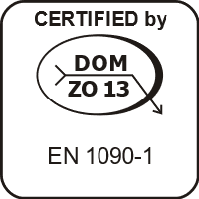

No ………………………………

1. Unique identification code of product: ……………………………………………………

2. Intended use(s): ………………………………………………………………………. ……………………………………………………………………………………………………

3. Manufacturer: ……………………………………………………………………………………….

4. Authorised Representative: ………………………………………………………….………. ……………………………………………………………………………………………………

5. POSV system: 2+

6. Harmonised standard: EN 1090-1:2009+A1:2011

Notified body: No 2570: DOM - ZO 13, s.r.o.

7. Declared property(ies): …………………………………………………………………….. ……………………………………………………………………………………………………… ………………………………………………………………………………………………………

8. Relevant technical documentation and/or specific technical documentation: …………… ……………………………………………………………………………………………………….

The properties of the aforementioned product comply with the set of declared properties. In compliance with Regulation (EU) No 305/2011, this declaration concerning properties is issued at the exclusive responsibility of the aforementioned manufacturer.

Signed on behalf of and in the name of the manufacturer at PLACE day DATE

Name, position and signature of worker: NAME, POSITION ………………………

